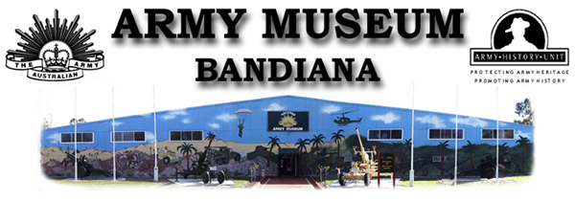

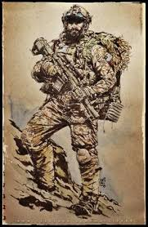

Educational Guide
and
Activity Kit

Secondary School

School Years 7–10

Gaza Ridge Barracks South, Bandiana Victoria 3694
Tel: 02 60552525
Email: reception.amb@gmail.com
SECONDARY SCHOOL
YEARS 7-10

As you walk around the museum, see if you can find answers to the following questions:

- Which war had the longest duration: World War 1, World War 2, or the Vietnam War? Place them in order from shortest to longest.

(a)___________________________duration___________

(b)___________________________duration___________

(c)___________________________duration___________

2. Why was Australia involved in World War 1 when it happened on the other side of the world? Did the issues directly involve Australia?
_____________________________________________________________________________________________________________________________________________________________________________________________________________________________________________________________________________________________

3. The involvement of women in the Australian Army has increased over the years. How were women involved in:

(a) World War 1:
___________________________________________________________________________________________________________________________________________________________________________

(b) World War 2:
___________________________________________________________________________________________________________________________________________________________________________

(c) Present day:

____________________________________________________________________________________________________________________________________________________________________________________________________________________________________

4. Find the Drip Rifle. This was a very clever invention used by the ANZACs at Gallipoli. What was its purpose and how did it work?

_____________________________________________________________________________________________________________________________________________________________________________________________________________________________________________________________________________________________

5. There are three reasons for soldiers being awarded medals:

(a) Doing brave things

(b) Places of service

(c) Length of service

(a) What is the most important medal that can be given to an Australian soldier?

(b) Name the Albury citizen who was awarded this medal in WW 1 and has an Albury road named after him.

_________________________________________________________

6. Anything purchased for the Army costs money and so must have a specific use – (what does it do and why?) What is the specific purpose of the following:

(a) Army vehicles having tracks, not wheels.

__________________________________________________________________________________________________________________

(b) Camouflage uniforms – (multiple colours in a seemingly random design)

___________________________________________________________________________________________________________________________________________________________________________

(c) Smoke grenade dischargers on tanks.

__________________________________________________________________________________________________________________

7. Find the Furphy Water Cart.

(a) What was it used for?

__________________________________________________________________________________________________________________

(b) The drivers of the Furphy cart often brought news and gossip to the soldiers, so the term – “Telling a Furphy” became part of Australian slang. So if someone told you a furphy, would you believe them or not?

Yes____ No____ Maybe ____

8. There are MANY career options available for those joining the Army now. List as many as you can that could be undertaken as part of a person’s military service.

______________________________________________________________________________________________________________________________________________________________________________________________________________________________________________________________________________________________________________________________________________________

9. Why is a chaplain (minister/padre) and a chapel part of military infrastructure?

__________________________________________________________________________________________________________________

10. (a) What do the letters PTSD stand for?

_________________________________________________________

(b) Does it relate to military personnel only or can the wider community also be affected?

___________________________________________________________________________________________________________________________________________________________________________

11. Soldiers from all wars brought back reminders of their journey - , photos, souvenirs, artwork, journals and diaries, letters to and from home etc.

Look at the various displays and choose your favourite one. Who was it by, what was it and why did you choose it? You may wish to draw it and /or copy details.

____________________________________________________________________________________________________________________________________________________________________________________________________________________________________________

